

User Research Report and Personas

Video Game Pricing Helper

Ding Liao (Ding), Hairong Wu (Jason), Zhuoyan Liu (Louise), Zest Chen

INFO 200 Problem Statement | AE | Locksley Kolakowski

# **Table of Contents**

**Table of Contents** 1

**Problem Brief** 2

**Existing Solutions** 3

Existing Solution 1 3

Existing Solution 2 4

Existing Solution 3 5

Existing Solution Conclusion Table 6

**Stakeholder Groups** 7

Stakeholder 1 7

Stakeholder 2 7

Stakeholder 3 7

**User Research** 8

**Surveys** 8

**Stakeholders’ Interviews** 9

User Interview 1 For Video Game Player 9

User Interview 2 For Game Developer 10

**User Personas** 11

**User Persona 1: Li Xiaohua** 11

**User Persona 2: Zhang Zishu** 12

**Conclusion** 13

**Bibliography** 13

**Appendix** 13

**Interview Notes** 13

**Survey Results** 15

# **Problem Brief**

We are producing a tool which could help make better decisions on games’ prices for both consumers and producers. Under current game markets, individual producers are hard to make money by producing games and players are extremely uncomfortable to make choices between these games. Therefore, with such a product can both players and game developers be more likely to produce and enjoy these meaningful game works.

# **Existing Solutions**

## Existing Solution 1

Website: [www.gog.com](http://www.gog.com)

GOG.com is an existing solution for our problem. It is a digital distribution gaming platform

where you can organize all the accounts you have in other different pc gaming stores like steam, Ubisoft, Blizzard and etc. People use it since GOG.com shows what game their friends are currently playing, whatever software or platform they use. For example, when you connect all your gaming accounts with GOG.com, you don’t have to log in to each platform to see which game your friends are playing. It does well on organizing all the games in one platform. Users do not need to switch platforms to buy the game. However, it falls short on comparing prices. Because it has its own GOG game store, for their profit they will not compare prices between other game selling platforms. Also, compared to other platforms there are fewer new games.

There are some news articles talking about this platform saying what are the pros and cons of GOG.com. They have similar opinions to mine that it is a good place to connect all game stores but the game on the platform is old.

News article: <https://www.pcmag.com/reviews/gogcom-for-pc>

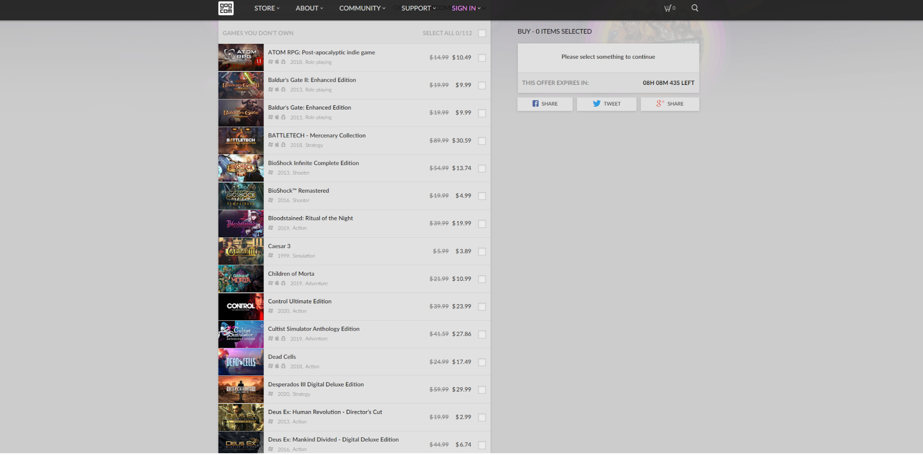

Figure 1 gog.com Website Screenshot

## Existing Solution 2

Website: [steamdb.info](https://steamdb.info/)

SteamDB is also a tool for those players to utilize. It is a web-crawling platform which provides live information of game prices and popularity in all regions from the world. It provides a clear view to showcase games with most players today, now and on average. It also allows its stakeholders to evaluate a specific game’s price under various markets to compare their pricing. Indeed, it could sometimes make mistakes on calculating those pricing rates, popularity and players. SteamDB does present a drawback on its equation to calculate games’ popularities and other status. However, it is still a great tool for people to utilize and analyze. In addition, the following link shows a great popularity of the usage of SteamDB and supports the power of its current functions.

SteamDB’s real practice posts: <https://steamcommunity.com/groups/SteamDB/announcements>

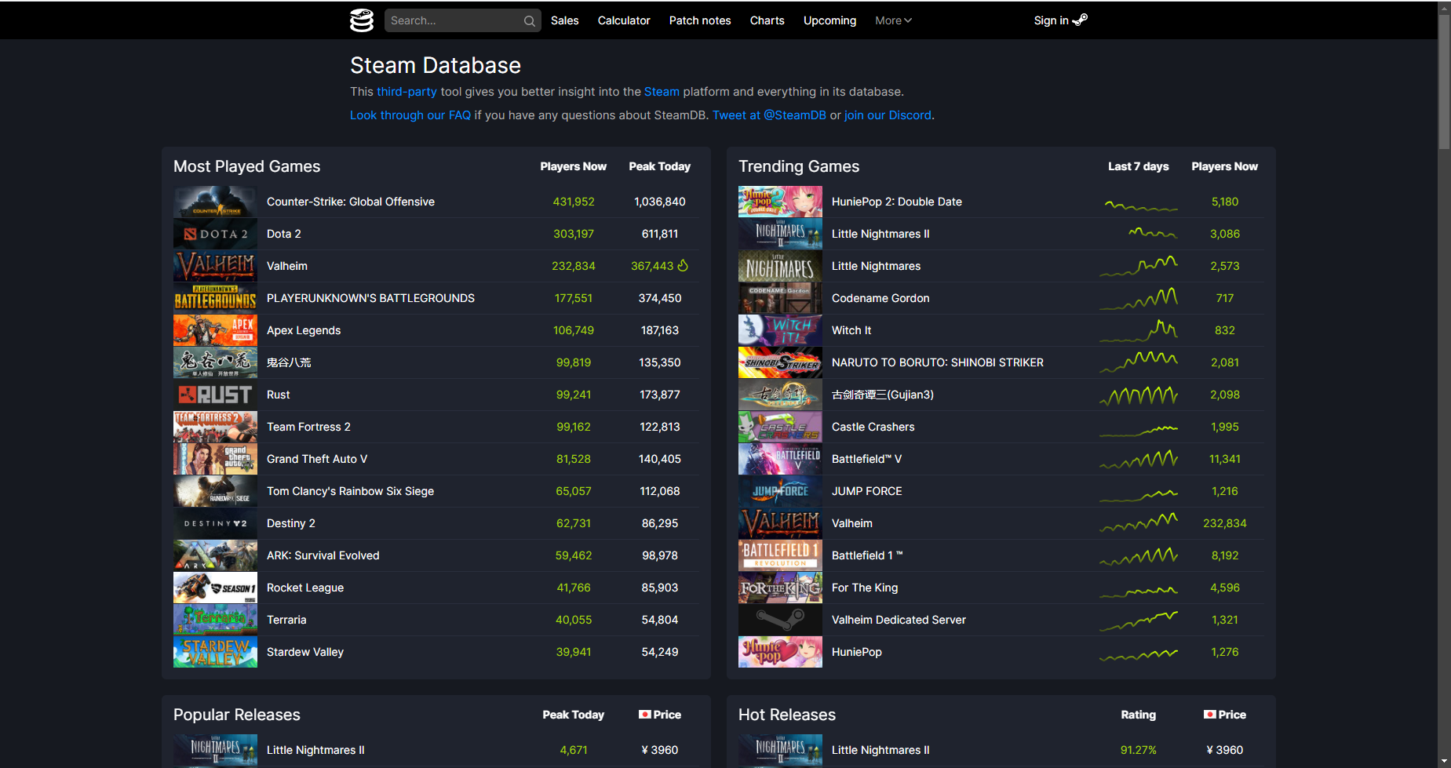

Figure 2 SteamDB Website Screenshot

## Existing Solution 3

Website: <https://gg.deals/>

The third existing solution is gg.deals. The basic function of it is to compare game prices on different platforms. People always want to use it to save money. It compares prices of PC games from over 40 digital shops in one place to help video game players buy games for the best possible price. Also, the Deals section showcases all of the best selling and most recently discounted games. That is what it does well on. However, it falls short on the comments of games. People are not able to review the comment to decide what games to buy.

Screenshot:

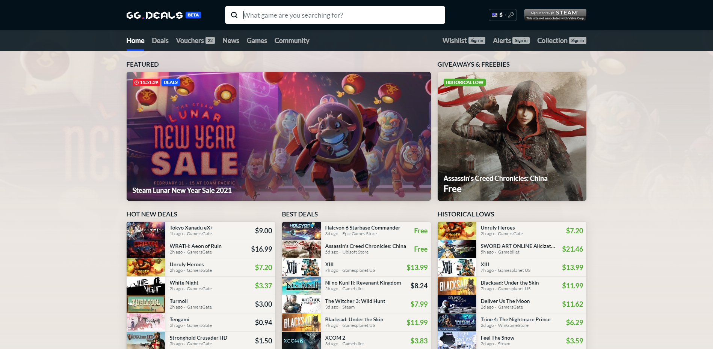

Figure 3 gg.deals Website Screenshot

## Existing Solution Conclusion Table

|  |  |  |  |
| --- | --- | --- | --- |
|  | **Existing Solution 1** | **Existing Solution 2** | **Existing Solution 3** |
| **What does the existing solution do well?** | Connect all game stores  30-refund window | Users can check prices for a specific game | Showcase all of the best selling and most recently discounted games  Price comparing tool on different platform |
| **Where does the existing solution fall short?** | Games are old  No prices comparison | Sometimes make mistakes on calculating prices | No comments section |
| **How are they similar?** | Have its own store  Game reviews  Past game prices  Sell pc games | Have its own store  Game reviews  Sell pc games | Past game prices  Sell pc games |

# **Stakeholder Groups**

## Stakeholder 1

One of the direct stakeholders of game price comparison websites is the community of video game players. By comparing the prices of the same game on different platforms, video game players can save some money to buy other items. By saving money, video game players can buy more and experience more games. While comparing prices, game players can watch the reviews of these games to decide whether they want to buy them or not.

## Stakeholder 2

Another one of the direct stakeholders of game price comparison websites is the developer of video games. Based on the respective prices in different platforms or regions which are influenced by the tax rate and other factors, developers can make better plans of updating the game and language conversion. If there is a practical tool for developers to better check and compare the prices of video games on different platforms, it will be much more convenient for game developers to decide the date of posting new updates and patches. Therefore, they can be more focused on the development process of the video game.

## Stakeholder 3

Another one of the direct stakeholders of game price comparison websites is publisher of video games. For the publisher and producer of video games, they earn profits directly from selling video games online. The tool of comparing prices in different platforms will have tangible help for them to set a proper selling price when they publish a game. By comparing prices of video games that are in the same categories but on different platforms, the publisher has a better understanding of how to maximize their profit by setting a proper price. Moreover, in a discount season, they can better decide the percent discount in different platforms to make sure they increase the selling.

# **User Research**

## **Surveys**

We counted the survey since we wanted to know their opinions whether game players need a game price comparing tool or not and understand the game players’ needs of using a game price comparison helper. This research method is appropriate for our design since it describes the general characteristics about a large group of people in the real world. Also, it gives us a general opinion of people other than our teams. The distribution method we used is that we sent our surveys to our family members, school friends, game developers and Discord servers which is a communicating tool for games to ensure the diversity of our result. We collected demographics data about occupation, and gender. These screen questions help us to avoid confounding variables. The critical question asks about the time duration of playing games and whether people are sensitive towards games that are different between each platform. Based on these questions, we distinguish whether the respondents are game lovers, have accounts on different platforms, care about the price of games and it is essential to build a game price comparison tool.

Link to the survey:

<https://forms.gle/dR1FQLJX6qGZZNcZ8>

Link to result:

<https://docs.google.com/spreadsheets/d/1pJMp3TJIK-1rFvIUNi5miU1hcqgWe939yhba28lVTjo/edit?usp=sharing>

We got 37 respondents. 40.5% of them are female and 59.5% of them are male. 32.4% of them are working 59.5% of them are students and 8.1% of them are retired. From this survey, we know that most of the game players around 73% have accounts on different platforms (did not exclude people who do not play games). People who spend a long-time playing games every day are more likely to have game accounts on different platforms, however their opinions towards the game price helper is different from our prediction. Half of them think this tool is useful and half of them are not. If there is such a price comparison tool, the answer is equally separate for yes, no and maybe. And I make a chart for the percentage of people who have accounts on different platforms and care for the price between different platforms or not. The data is incredible that 92.6% will care about the price for the same game in different platforms but only one third of them will use it which means whether the user will use it or not, not only depends on their needs but also the design of the tool itself.

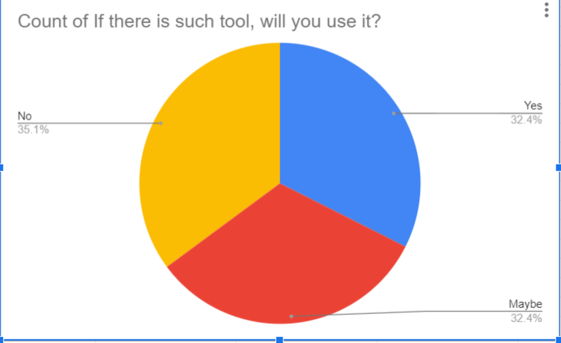

Figure 4 Survey Result - 1

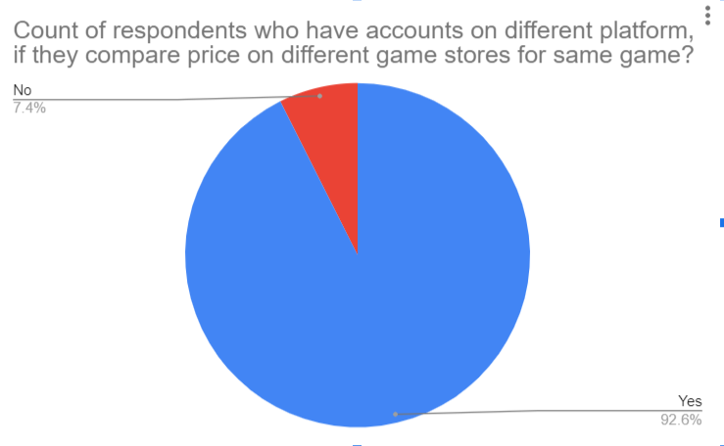

Figure 5 Survey Result – 2

## **Stakeholders’ Interviews**

### User Interview 1 For Video Game Player

The interviewed object is a video game player who frequently purchases video games online and spends the majority of time playing video games. The purpose of the interview is the information collecting of how she purchases video games in the popular online platform, such as steam, origin, and Ubisoft, and the choice-making when comparing prices of same video games in different platforms. Interview is an appropriate research method because it contains more specific questions that can target our goal which is understanding the importance of price-comparing when it is relevant to a specific and classic type of person. The key question asked is the degree of help of price-comparing tools when purchasing video games, because this is the ultimate goal of the project which is designing a practical tool of price comparison tool.

After the interview with the video game player, there were several key insights and learnings. First of all, the price-comparison tool indeed has tangible help to a video game player when she is purchasing games. Secondly, it is better designed as an expansion tool associated with different game platforms. In addition, she gives the idea of generating algorithms to the tool to calculate the cheapest price. We learned that the needs of price-comparing tools are inelastic, there are actually demands for gamers to compare the price of video games on different platforms. Moreover, it needs to be practical and concise. For the user interface, it has to be easily manipulated and concise. It should not be a library website, but a tiny digital dictionary. For more visualizing the frame and structure of our design, she gave an instance of Grammarly to briefly introduce how an extension tool perfectly works.

### User Interview 2 For Game Developer

We interview a game developer who focuses on producing individual games on TapTap and Google Play market for those Android users. We want to learn about the factors that affect his pricing choices to publish a game within mobile games’ market. In addition, doing an interview helps us to have a better understanding of developers’ side in a game market, instead of players’ view. We asked the developer about the audiences and choices of elements in a game work he is considering. We also wondered about the costs to produce a mobile game and the promotion and other options he works hard on to earn a revenue for living. These questions are made based on the purpose we want to pursue, which is to better analyze a game’s pricing rate not only in various regions and countries but also compare to other games with the same topic.

By interviewing an individual game producer, we know more about why those published games have the prices appearing to their players. Games designed for those youth players, such as children and students would have a lower price and even can be free to play. These games are usually made to facilitate a game production team and raise their popularity. To make money from these kinds of games, game producers would like to create in-app purchases or paid add-ons, which would make the “paying” process optional. For players who are college students or current workers mainly under thirty-five, a game is more likely to be published with a higher price between dozens and hundreds of dollars. What’s more, if a game costs a lot during its production process, developers and publishers would operate it with more add-on and in-game purchase contents, such as developing a character and weapon drawing systems. This appears a lot in current game markets, especially in China and Japan.

# **User Personas**

## **User Persona 1: Li Xiaohua**

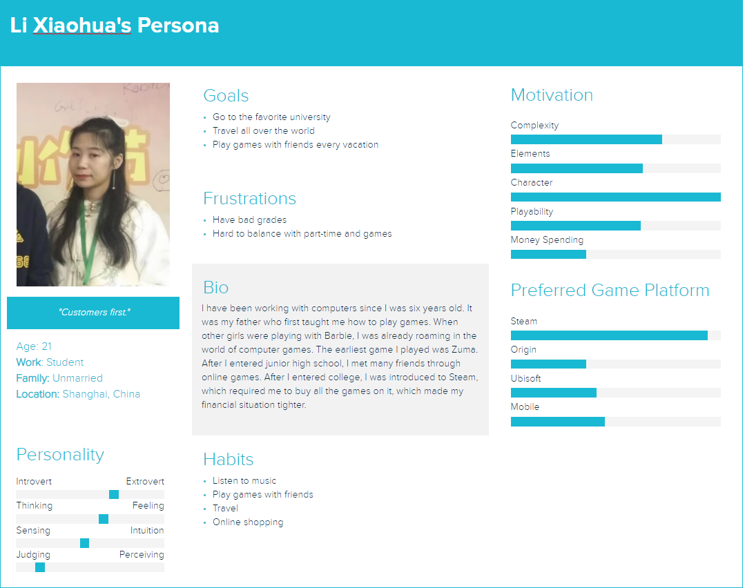

## **User Persona 2: Zhang Zishu**

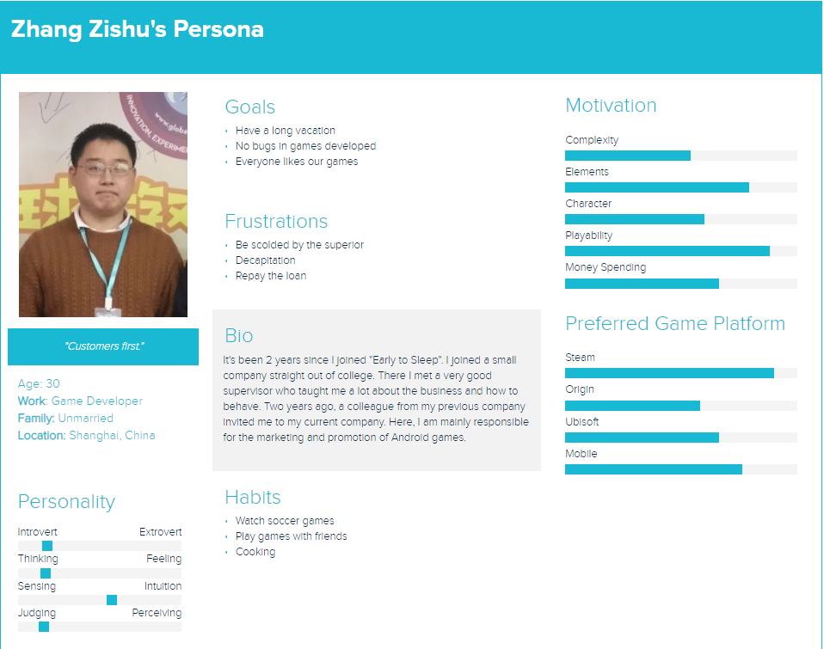

# **Conclusion**

Through these activities, we realized that stating a problem and collecting data to solve it is not an easy task. After stating a possible problem, we collected some people’s opinions about the topic we were studying through a survey. After that, we found several existing temporary solutions and compared the advantages and disadvantages between them. Then, we found a game player and a game developer to interview and got information from these two types of direct stakeholders. Our next step is to analyze current data and try to develop a better and more accessible solution for video game players, those game producers and publishers.

# **Bibliography**

GameDealsMeta. (2020). *GG.deals is no longer allowed.* From Redidit: https://www.reddit.com/r/GameDealsMeta/comments/czp63f/ggdeals_is_no_longer_allowed/

Minor, J. L. (2020 , 8 14). *GOG.om Review | PCMag*. From PCMag: https://www.pcmag.com/reviews/gogcom-for-pc

*SteamDB - Community*. (2021, 2 14). From Steam Community: https://steamcommunity.com/groups/SteamDB/announcements\

# **Appendix**

## **Interview Notes**

**Interview to Xiaohua Li (Game Nickname: Pillow)**

**Interviewer**: What games platform do you use the most often? What game do you play the most often, and where you purchased it?

**Respondent**: Steam, no doubt. I play various types of games, most of the game are purchased on steam and origin.

**Interviewer**: Do you think a price-comparison tool for video games on different platforms helps you, specifically when you are purchasing video games.

**Respondent**: Definitely it helps, I believe it also helps many other gamers when they are buying games. It helps me save money for the next brand new game. People’s needs to it will be inelastic.

**Interviewer**: What kinds of frame and structure do you expect for a price-comparison tool

**Respondent**: I think it must be user-friendly. It should be easy to use and concise. From my perspective, I expect it to be an extension tool that can attach to different game platforms or like a tiny digital dictionary that is convenient to look up. When I click on some buttons of this tool, it can immediately pump out the cheapest price of this game.

**Interviewer**: What kinds of examples can you give us for reference?

**Respondent**: Just like Grammarly, an extension tool that helps to correct people’s grammar. It is simple to use and associated with many websites and companies, such as Google. Another example may be Oxford Dictionaries, it is a digital dictionary. that is very concise and easy to look up. You can just need to put it aside and use it in need.

**Interviewer**: Do you think that we should just focus on serval major game platforms?

**Respondent**: I think your target is right because the majority of people are using the hot game platform, such as steam. Some platform is too small that can be really ignored.

**Interview to Zishu (Producer Nickname: Purple Math)**

**Interviewer**: What kinds of games have you produced and are currently making?

**Respondent**: Mobile Games. I publish games that are published on TapTap and Google play. I usually produce game works that are focusing on game play and design, and sometimes on its art works.

**Interviewer**: Who are your games’ main audiences?

**Respondent**: Usually students, college students, and workers who are just graduated or under thirty or thirty-five years old. I also do market research as well, finding out what kinds of game people are looking for.

**Interviewer**: As you’ve mentioned before, why sometimes focus on a game’s art design?

**Respondent**: Oh, it’s because that a delicate art design would cost a lot of money, and it's always hard to find artists who could provide art resources fitting your tastes. Therefore, I usually focus on game design, such as each level and the data and numerical design. (fyi, I used to be a numerical programmer)

**Interviewer**: Do you make your lives by producing **individual** games?

**Respondent**: Eer, not really. It is really hard to gain revenue by selling individual games, especially in China, as you’ve known. We used to provide in-game purchases and paid add-ons to make our lives. However, it doesn’t work so far, and the only way we can sell games is the game platform, Steam. However, it can be hard to publish one game on Steam and we have tradeoffs to do so.

Thus, I’m now making my own games, individuals games as a part-time interest, and make money by getting hired from a game company and working for them.

**Interviewer**: Last but not least, if there exists such a tool that could help you analyze the current game market and make a competitive pricing decision, would you prefer to utilize it?

**Respondent**: I would say, yes, and please develop such a tool. We, individual developers, are experts in designing games and producing games. However, we rarely know markets. We could cooperate with several huge publishers, but there’s tradeoff, we can rarely receive money from them, because most of the revenue would be taken from them. So, if there’s a tool that can help us to learn the market and decide our pricing or seasonal discounts for sale, I would be extremely grateful to use it.

## **Survey Results**

|  |  |  |  |  |  |  |  |
| --- | --- | --- | --- | --- | --- | --- | --- |
| **TimeStamp** | What is your gender? | What is your currently position? | How long do you play games everyday? | Do you have accounts on different game stores? | Do you compare price on different game stores for same game? | What is your opinions towards a tool that compare prices between different game stores? | If there is such tool, will you use it? |
| 02/14/2021 01:14:39 | Male | Student | longer than 6 hours | Yes | Yes | 4 | Yes |
| 02/06/2021 06:27:24 | Male | Student | 0 - 1 hour | Yes | Yes | 5 | Yes |
| 02/10/2021 03:00:51 | Male | Student | 1 - 3 hours | No | No | 1 | Maybe |
| 02/07/2021 23:58:59 | Male | Work | 3 - 6 hours | Yes | Yes | 3 | Maybe |
| 02/03/2021 21:19:49 | Male | Work | 3 - 6 hours | Yes | Yes | 5 | Maybe |
| 02/05/2021 23:39:35 | Male | Retired | longer than 6 hours | Yes | Yes | 2 | Maybe |
| 02/11/2021 08:53:42 | Female | Student | 1 - 3 hours | No | Yes | 1 | No |
| 02/14/2021 21:56:15 | Male | Retired | longer than 6 hours | Yes | Yes | 4 | Yes |
| 02/11/2021 15:55:57 | Female | Student | 1 - 3 hours | Yes | No | 2 | Maybe |
| 02/08/2021 02:49:12 | Male | Work | 1 - 3 hours | Yes | Yes | 4 | Yes |
| 02/10/2021 01:20:14 | Female | Work | 3 - 6 hours | Yes | Yes | 5 | Maybe |
| 02/02/2021 05:56:34 | Male | Student | 1 - 3 hours | Yes | Yes | 4 | Yes |
| 02/13/2021 20:35:32 | Female | Student | 1 - 3 hours | Yes | Yes | 3 | Maybe |
| 02/02/2021 07:34:27 | Male | Student | 1 - 3 hours | Yes | Yes | 2 | No |
| 02/16/2021 12:45:22 | Female | Retired | 0 - 1 hour | No | No | 1 | No |
| 02/05/2021 16:22:32 | Female | Student | 1 - 3 hours | Yes | Yes | 4 | Yes |
| 02/16/2021 15:52:37 | Female | Work | 1 - 3 hours | No | No | 1 | No |
| 02/08/2021 08:24:35 | Male | Student | 1 - 3 hours | Yes | Yes | 5 | Yes |
| 02/10/2021 15:45:09 | Male | Student | 1 - 3 hours | Yes | Yes | 4 | No |
| 02/11/2021 14:06:37 | Male | Student | longer than 6 hours | Yes | Yes | 5 | No |
| 02/02/2021 11:34:23 | Male | Work | 1 - 3 hours | Yes | Yes | 4 | Yes |
| 02/06/2021 14:08:10 | Female | Student | 3 - 6 hours | Yes | Yes | 4 | Yes |
| 02/09/2021 10:47:27 | Male | Student | 0 - 1 hour | Yes | Yes | 1 | No |
| 02/04/2021 11:02:58 | Female | Student | 1 - 3 hours | No | No | 1 | No |
| 02/16/2021 15:13:39 | Male | Student | longer than 6 hours | Yes | No | 3 | Maybe |
| 02/02/2021 02:40:14 | Male | Work | 1 - 3 hours | No | Yes | 2 | No |
| 02/15/2021 23:21:27 | Male | Work | longer than 6 hours | Yes | Yes | 2 | Maybe |
| 02/13/2021 14:59:04 | Male | Student | longer than 6 hours | Yes | Yes | 3 | Maybe |
| 02/12/2021 09:20:08 | Female | Student | 0 - 1 hour | No | No | 1 | No |
| 02/13/2021 23:48:10 | Female | Student | longer than 6 hours | Yes | Yes | 3 | Yes |
| 02/15/2021 08:18:27 | Male | Work | 1 - 3 hours | No | No | 3 | No |
| 02/04/2021 04:22:08 | Female | Student | longer than 6 hours | Yes | Yes | 5 | Maybe |
| 02/02/2021 10:02:44 | Female | Student | 3 - 6 hours | No | No | 1 | No |
| 02/09/2021 04:52:13 | Female | Student | longer than 6 hours | Yes | Yes | 3 | Yes |
| 02/14/2021 21:00:47 | Male | Work | 1 - 3 hours | Yes | Yes | 4 | Yes |
| 02/07/2021 06:49:15 | Male | Work | 1 - 3 hours | No | No | 1 | No |
| 02/06/2021 13:36:16 | Female | Work | 0 - 1 hour | Yes | Yes | 3 | Maybe |

Results can also be view via google sheet here: <https://docs.google.com/spreadsheets/d/1pJMp3TJIK-1rFvIUNi5miU1hcqgWe939yhba28lVTjo/edit?usp=sharing>